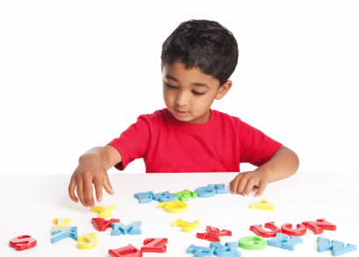
EARLY CARE AND EDUCATION RESOURCES
IN MY COMMUNITY
Program | Serves birth-3-years old | Serves  3-5 years old | Statewide list of local/county contacts | What is this program called in my community? | Contact Name, Address,  Email, Phone
Child Care Resource & Referral (CCR&R) (Provides information and resources only) | X | X | https://ocfs.ny.gov/main/childcare/referralagencies.asp
Child Care Subsidies | X | X | https://ocfs.ny.gov/main/childcare/localdss.asp
Head Start/  Early Head Start | X  (Early Head Start) | X  (Head Start) | https://eclkc.ohs.acf.hhs.gov/center-locator
Pre-K |  | X  (4-year-olds & in certain school districts programs for 3-year-olds) | http://www.p12.nysed.gov/upk/upkdirectory.html  For NYC, contact Pre-K Outreach: 718-935-2009
Early Intervention | X |  | https://www.health.ny.gov/community/infants_children/early_intervention/county_eip.htm
Preschool  Special Education |  | X | Contact the local school district’s Chairperson of the Committee on Special Education by visiting http://eservices.nysed.  gov/sedreports/list?id=1 and searching for “School Districts: Active School Districts Director of Special Ed Info.” For NYC, see: https://www.schools.nyc.gov/special-education/help/cpse-cse
Home Visiting  Programs | X |  | https://www.health.ny.gov/community/pregnancy/home_visiting_programs/pregnant_parenting_fam.htm#list
McKinney-Vento Liaison |  |  | https://nysteachs.org/lea-liaisons/
Shelter and Housing Providers |  |  | https://otda.ny.gov/workingfamilies/dss.asp (family shelters)  https://www.nyscadv.org/find-help/program-directory.html (family shelters for survivors of domestic violence)  https://otda.ny.gov/programs/housing/providers/ (housing providers)  https://www.lawhelpny.org/ (eviction prevention)
Other local
resources:
My Early Childhood
Go-To Resource:
There’s more! In addition to the above resources, you can get information and referrals for many different types of services, including early care and education services by:
- Calling 211 (outside of New York City) or 311 (New York City)
- Visiting https://211nys.org/find-services (outside of New York City) or https://access.nyc.gov/ (New York City).
Also, make sure to check places like libraries, family resource centers, community action centers, programs for pregnant and parenting teens, etc. for additional local resources.

